
FACULTY OF TECHNOLOGY AND ENGINEERING
DEVANG PATEL INSTITUTE OF ADVANCE TECHNOLOGY
AND RESEARCH

DEPARTMENT OF COMPUTER ENGINEERING

A.Y 2026 – 27 Semester – 3

LAB MANUAL

CSUC201 Fundamentals of Data Structures and Algorithms

Practical 3: Counting-Based, and Digit-Based Strategies Sorting Algorithms: Comparison-Based,

Practical Aim: To implement and compare multiple sorting algorithms and develop the ability to reason about which sorting strategy suits a given situation.
Problem 1 :
A teacher has a stack of student answer sheets with marks written on them and needs to arrange them in order before entering grades. She tries three different methods: in the first, she repeatedly compares adjacent sheets and swaps them if they are out of order; in the second, she finds the lowest-marked sheet each time and places it at the front; in the third, she picks each sheet one by one and inserts it into its correct position among the already-arranged sheets. Implement all three methods and for each one, print the sorted order of marks.
Describe how each of the three methods works in your own words. If the sheets were already in order before the teacher started, which method would finish the fastest and why?
For Code:
GitHub Repo Link:
https://github.com/meet-3834/FDSA/tree/main/Practicals/Practical%201

Output:
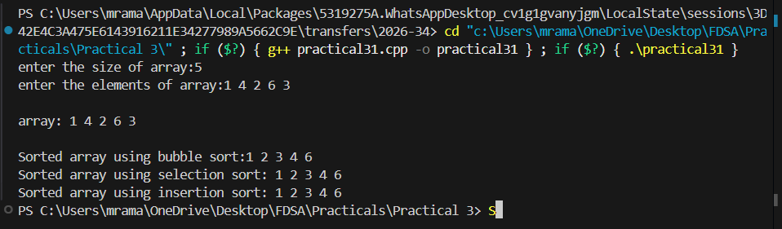
Problem 2 :
A paint shop has buckets labeled with one of three colour codes - 0, 1, or 2 - but they are stored in a random order. The shop owner wants all Os together, then all 1s, then all 2s, without using any extra storage. Given the list of colour codes, rearrange them in place and print the result.
Describe the approach you used. Does your solution make more than one pass through the list? Can you think of a way to do it in exactly one pass?
For Code:
GitHub Repo Link:
https://github.com/meet-3834/FDSA/tree/main/Practicals/Practical%202
Output:
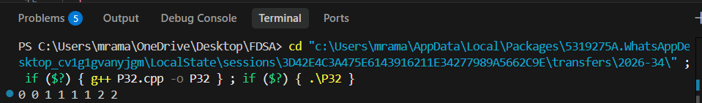

Key Questions / Analysis / Interpretation to be Evaluated During/After:
Implementation
- One of the three methods can detect early that the list is already sorted and stop without doing any more work. Which method is it, how would you add that detection, and why can the other two not do the same?
Sol: Bubble Sort. If no swaps occur in a pass, the list is already sorted and the algorithm stops. Selection Sort and Insertion Sort still need to continue their comparisons, so they cannot use this early-stop check as effectively.

2. If your solution makes two passes through the list, can you identify which decision in your logic forces the second pass? Is there a way to restructure that decision to eliminate it?
Sol:
The first pass counts the number of 0s, 1s, and 2s, and the second pass rearranges them based on those counts. And Yes, The Dutch National Flag algorithm uses three pointers to place 0s, 1s, and 2s in their correct positions in a single pass without extra storage

Outcome/Conclusion:
I am able to implement multiple sorting algorithms, trace their execution step by step, compare their behaviour on different inputs, and articulate why certain sorting approaches work only under specific input conditions.

